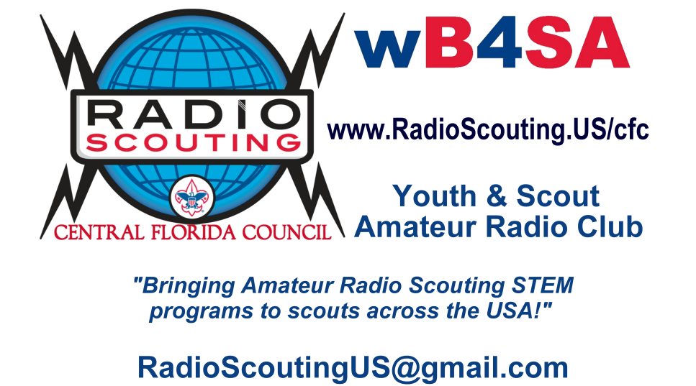**June 26 & 27**  
Youth and Scouts are invited   
to visit and learn about   
Radio Communications   
during 2021 ARRL Field Day

ARRL Field Day is the single most popular on-the-air radio event held annually in the US and Canada. On the fourth weekend of June of each year, thousands of radio amateurs gather with their clubs, groups or simply with friends to operate from remote locations, contacting other hams, youth and scouts around the world without infrastructure. Many groups practice their disaster preparedness by setting up in the same conditions as a disaster: no phones, no internet, no grid power...

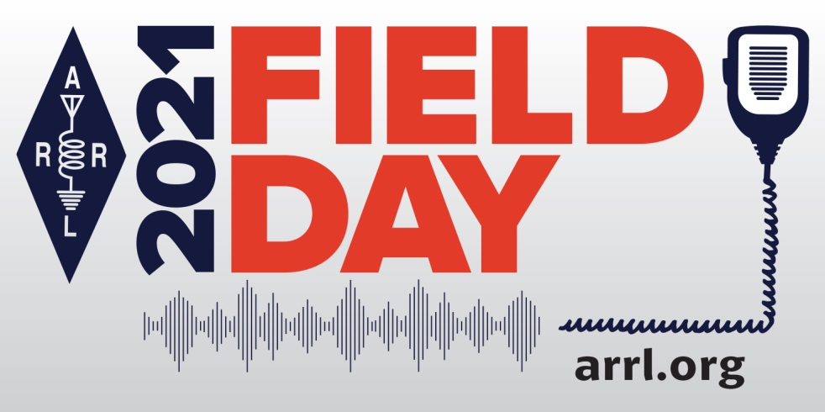**Field Day can be a picnic, a campout, practice for emergencies,   
an informal contest and, most of all, FUN!**

**Find your local event here:**<https://www.arrl.org/field-day>  
[**http://www.kn4mdj.com/fieldday/**](http://www.kn4mdj.com/fieldday/)

*73 & YIS (yours in scouting),*Ken Lyons, KN4MDJ  
ARRL Southeastern Assistant Division Director - Radio Scouting*,* [*www.kn4mdj.com*](http://www.kn4mdj.com) *"Bringing Amateur Radio Scouting programs to a half million scouts in AL, GA, FL, PR, USVI"*

Please forward this to your district and youth leaders. **It's hoped that every ACTIVE PACK or TROOP will get a copy of this email/attachment.**

|  |  |  |
| --- | --- | --- |
| **ARRL Section – Alabama** S9-001 Greater Alabama Council S9-006 Black Warrior Council S9-091 Chattahoochee Council S9-005 Tukabatchee Area Council S1-003 Alabama-Florida Council S1-773 Gulf Coast Council – Pensacola, FL S1-004 Mobile Area Council S1-302 Choctaw Area Council | **ARRL Section - Northern Florida** S1-773 Gulf Coast Council – Pensacola, FL S4-664 Gulf Stream Council - Tallahassee, FL S4-087 North Florida Council - Gainesville, FL S4-083 Central Florida Council - Orlando, FL  **ARRL Section - West Central Florida** S4-089 Greater Tampa Bay Area Council - Tampa, FL S4-088 SWFL Council - Fort Myers, FL | **ARRL Section - Georgia** S6-556 Cherokee Area Council S5-903 Georgia-Carolina Council S9-100 Northwest Georgia Council S9-101 Northeast Georgia Council S9-092 Atlanta Area Council S9-095 Flint River Council S9-091 Chattahoochee Council S9-096 Central Georgia Council S9-099 Coastal Georgia Council S9-098 South Georgia Council S4-664 Gulf Stream Council - Tallahassee, FL |
| **ARRL Section - Puerto Rico**  BSA Puerto Rico Council (Concilio de Puerto Rico)  – BSA National Capital Area Council - NE Region | **ARRL Section - Southern Florida** S4-085 Gulf Stream Council - West Palm Beach, FL S4-084 South Florida Council - Miami, FL | **ARRL Section - US Virgin Islands**  BSA USVI (St. Croix, St. Thomas and St. John.)  – BSA National Capital Area Council - NE Region |

I've reached out to 40+ ham clubs across our division and all their responses have been positive and many will welcome scouts/youth to visit this year. **This is an IN-PERSON learning event**, so if your local troops & cubs are doing activities this will be something special for them. Most county governments will be activating their Emcom and Mobile command trailers to assist on this day. Some EOC's (emergency operation centers) will also activate to take part, ensuring that all aspects of communications are tested.

Field day is an ARRL event that is done yearly, just before hurricane season to ensure everyone is ready for disaster communications. The Florida panhandle might remember a bad week with no cellphones...a dozen emcom trailers were sent up to help restore temporary services and get disaster messages and info relayed to state agencies.  
   
The BSA & World Scouting have an event called JOTA (Jamboree-on-the-Air), 3rd weekend of October where MILLIONS of scouts across the world get on the air and internet to interact, dozens of cub and scout rank requirements can be fulfilled during that weekend. **If you council has an active program or someone that normally sets up your events, I'd like to get their contact info** to co-ordinate trans-council and trans-national events through the year and on JOTA.

Here is a list of councils that I know about who have an active Radio Scouting program: [www.RadioScouting.US](http://www.RadioScouting.US)    
If your council is not on the list... you might want to see why you are missing a program ongoing since 1957 that leads to tech careers, 5G, scholarships and jobs in the telco industries...and a cornerstone of many STEM programs as it combines all the sciences. (Youth, as young as 8, have earned their federal radio license before their drivers license!)

For those that don't know me, the position or what all this is about... here is my appointed position and role.  
  
**ARRL Southeastern Division - Assistant Division Director for Radio Scouting**

Promote Radio Scouting activities and opportunities in both the Boy Scout and Girl Scout programs covered by the Division. Participate in regular discussions with ARRL HQ, National BSA and National GSUSA regarding the Radio Scouting program and how best to improve the program nationally and in the Division.   
Areas covered: 31 BSA councils, 14 GSUSA councils in Alabama, Georgia, Florida, Puerto Rico, US Virgin Islands for a **half million scouts/youth**.

There is a long relationship between the BSA and ARRL that began with the development of the Wireless Merit Badge in 1918 — now the Radio Merit Badge. This relationship was formally recognized through a 2011 Memorandum of Understanding. <http://www.arrl.org/files/file/Public%20Service/MOUs/BSAARRLMOUFINAL.pdf>

ARRL will serve as contributing editor to the **Radio Merit Badge** publication (those sections pertaining to Amateur Radio), will assist with the review, creation and modification of requirements as necessary, and will assist in developing course material, lesson plans, and other resources for teaching the Radio Merit Badge to Scouts.  
To the extent that BSA desires, ARRL will contribute to the content of the **Electricity, Electronics, and Emergency Preparedness and Communications merit badge** publications, especially in areas that currently, or may in the future, pertain to Amateur Radio.